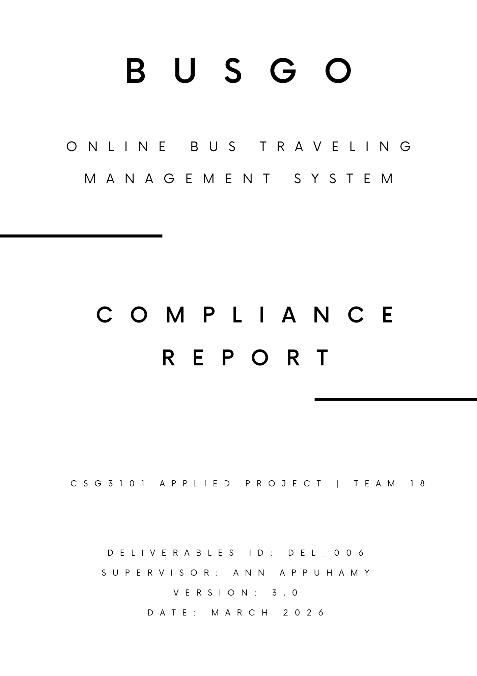

Executive Summary
This Compliance Report (DEL_006) documents the security, data protection, regulatory, and payment compliance measures implemented within the BusGo Online Bus Travelling Management System, developed as part of CSG3101 Applied Project at Edith Cowan University by Team 18 Syntax & Sec. BusGo is scoped to the Colombo District, Sri Lanka, and comprises four applications: BusGo Client (passenger mobile app), BusGo Drive (driver mobile app), BusGo Scanner (QR boarding app), and BusGo Axis (admin web dashboard), all backed by a Node.js/Express API, PostgreSQL via Supabase, and integrated with PayHere for payments and Firebase Cloud Messaging (FCM) for push notifications.
Public bus transportation systems that incorporate digital management require robust compliance frameworks to ensure user data protection, secure authentication, and regulatory adherence (Gunawardene, 2017) This report evaluates BusGo's compliance across four domains:
- Security Compliance — authentication (JWT), authorisation (RBAC), encryption, and input validation
- Data Protection and Privacy — partial GDPR alignment and responsible data handling practices
- Sri Lanka Personal Data Protection Act (PDPA) No. 9 of 2022 — primary legal obligation
- Payment Compliance — PayHere integration and PCI-DSS scope management

Compliance Status Overview
Security Compliance (JWT / RBAC / TLS / Encryption) → Compliant
Data Protection / Privacy (GDPR Partial Alignment) → Partial
Sri Lanka PDPA No. 9 of 2022 → Partial (academic scope)
Payment Compliance (PayHere / PCI-DSS) → Partial (full audit out of scope)

Contents
1. Executive Summary 2
2. Scope and Limitation 4
3. Security Compliance 4

Scope and Limitation
This compliance report applies to BusGo as developed within the CSG3101 Applied Project academic context. The following limitations apply to the current version of the system:
- Full PCI-DSS compliance requiring formal external auditing services is out of scope.
- Full GDPR compliance (e.g., PCI audit certification) is out of scope due to cost constraints.
- The system is scoped exclusively to the Colombo District and does not reflect wider regions.
- Bug fixation after deployment and user training are out of scope.
- iOS device compatibility is not guaranteed.

Academic software prototypes are commonly subject to scope limitations that distinguish them from production-grade systems (Per Runeson et al., 2012). All compliance measures documented here represent best-effort implementation appropriate for a controlled academic environment.

Security Compliance
BusGo incorporates multiple security layers across authentication, authorisation, data storage, and transport. Security controls align with best practices established by the Open Web Application Security Project (OWASP Top 10:2021, 2021) and the National Institute of Standards and Technology digital identity guidelines (Grassi et al., 2017).

Authentication – Json Web Tokens (JWT)

